1. Create view V_MARKS with roll no, student name, subject code, marks of all CSE students.

CREATE VIEW V_MARKS AS SELECT ROLLNO,NAME,SUB_CODE,MARKS FROM RESULT INNER JOIN STUDENT ON ROLL_NO=ROLLNO WHERE DEPTCODE='CSE';

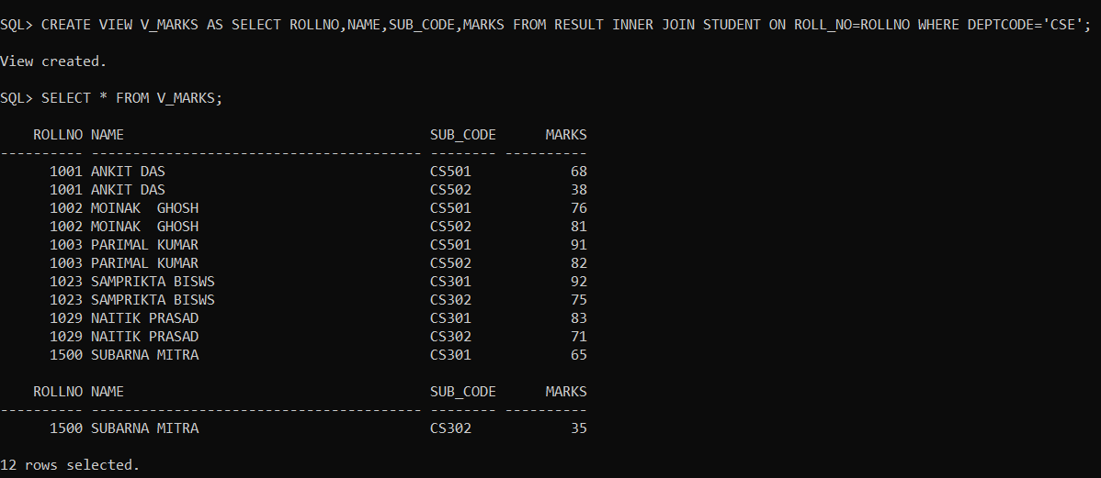

1. Create view V_CLASSTAKEN with subject code, subject name, Faculty code, faculty name where the subject is taught by that faculty.

CREATE VIEW V_CLASSTAKEN AS SELECT SUBJECTCODE,SUBJECTNAME,FID,NAME FROM SUBJECT INNER JOIN FACULTY ON FID=TEACHER;

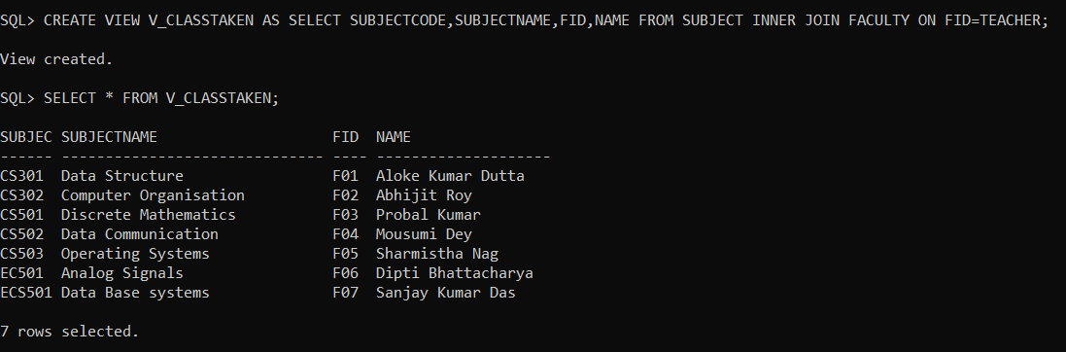

1. Create view V_SUBJECT with subject_code, subject_name, teacher name where number of student os more than 1.

CREATE VIEW V_SUBJECT AS SELECT SUBJECTCODE,SUBJECTNAME,NAME FROM SUBJECT,(SELECT SUB_CODE,COUNT(SUB_CODE) AS SUB_COUNT FROM RESULT GROUP BY SUB_CODE),FACULTY WHERE SUB_COUNT>1 AND SUB_CODE=SUBJECTCODE AND FID=TEACHER;

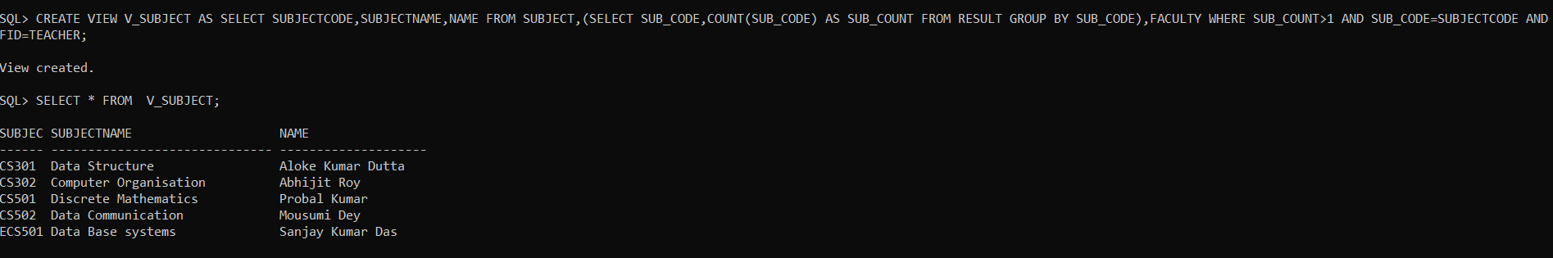

1. Create view V_STUDENT with student name, roll number, department who appeared in at least one examination.

CREATE VIEW V_STUDENT AS SELECT NAME,ROLL_NO,DEPTCODE FROM STUDENT WHERE ROLL_NO IN (SELECT ROLLNO FROM RESULT);

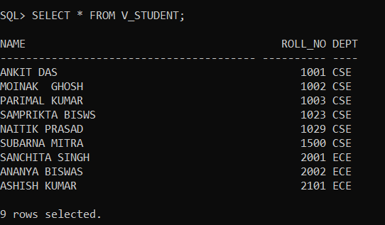

v. Create view V_DEPT with dept code, semester, and number of student with more than 75 marks in at least one subject.

CREATE VIEW V_DEPT AS SELECT DEPTCODE,SEMESTER,COUNT(DISTINCT(ROLLNO)) AS STUD_COUNT FROM SUBJECT,RESULT WHERE MARKS>75 GROUP BY(DEPTCODE,SEMESTER);

